CERVICAL SCREENING INFORMATION

Did you know HPV causes 99% of all cervical cancers?  Your smear test now screens for HPV. HPV testing is more effective, that’s why if no HPV is found it’s safe to wait 5 years between tests.  Visit https://www.nhsinform.scot/healthy-living/screening/cervical/cervical-screening-smar-test | 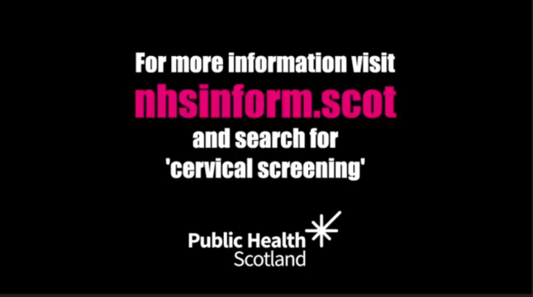
Did you know that 1 in 2 people who learn they have HPV don't know what it is? We want to see that change, so that fewer people feel confused or worried when they learn that they have HPV. Ready to get the facts with @JoTrust?  https://www.jostrust.org.uk/test | 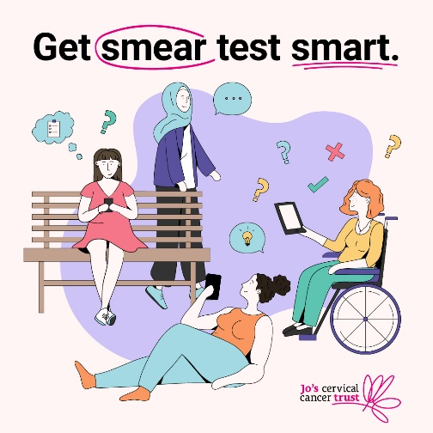
Around six women are diagnosed with cervical cancer every week in Scotland. Your smear test now screens for HPV which causes 99% of cervical cancers but has no symptoms.

Visit NHS inform for more information.
https://www.nhsinform.scot/healthy-living/screening/cervical/cervical-screening-smear-test

Did you know HPV causes 99% of all cervical cancers? The cervical screening test checks your cervix for HPV and can stop cervical cancer before it starts. Ready to get the facts?

https://www.jostrust.org.uk/test

